Shivaji University, Kolhapur
Department Of Technology
Computer Science and Technology Program
Placement Record (2025-2026)

Sr. No. | Name of Student | Photo | Company | Job Role | Package  (In Rs.)
1 | Ms. Sakshi Jadhav |  | Infosys | System Engineer | 3.6 LPA
2 | Ms. Srushti Kale | 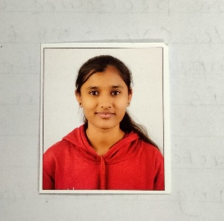 | Infosys | System Engineer | 3.6 LPA
3 | Mr. Hrushikesh Yalmar |  | ApMoSys  QSpiders | Software Tester  Trainee Engineer | 2.5 LPA  2 LPA
4 | Ms. Shraddha Ravindra Jeurkar |  | Qspiders  The Kiran Academy | Trainee Engineer  Trainee Engineer | 2 LPA  2 LPA
5 | Mr. Shridhar shivaji nimbalkar | 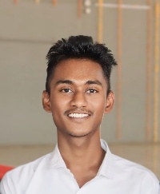 | Qspiders  The Kiran Academy | Trainee Engineer  Trainee Engineer | 2 LPA  2 LPA
6 | Mr. Neha Umesh Sawant | 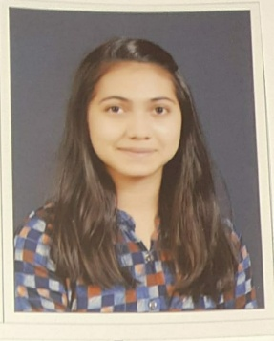 | Qspiders  Cyber Success | Trainee Engineer  Trainee Engineer | 2 LPA  2 LPA
7 | Mr. Himanshu Charak |  | QSpiders | Trainee Engineer | 2 LPA
8 | Mr. Dattaraj Rangrao Kadam | 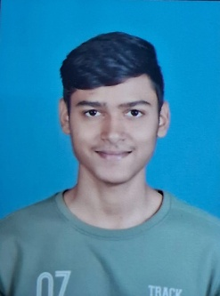 | QSpiders | Trainee Engineer | 2 LPA
9 | Mr. Samiksha Tatoba Pawar | 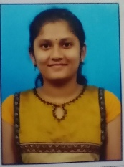 | Qspiders  The Kiran Academy | Trainee Engineer  Trainee Engineer | 2 LPA  2 LPA
10 | Mr. Siddhi Kishor Patil | 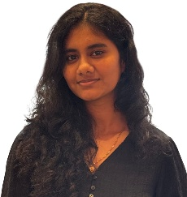 | QSpiders | Trainee Engineer | 2 LPA
11 | Mr. Shrutika Ananda Mahadik |  | QSpiders | Trainee Engineer | 2 LPA
12 | Ms. Priyanka Umesh Pawar | 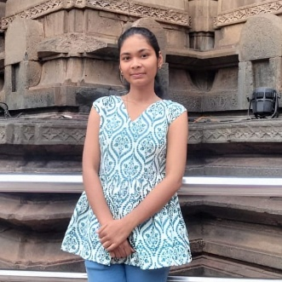 | QSpiders | Trainee Engineer | 2 LPA
13 | Ms. Sejal Ramesh Chikode | 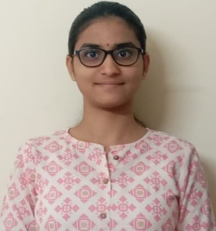 | QSpiders | Trainee Engineer | 2 LPA
14. | Ms. Amisha Akhtar Mulani | 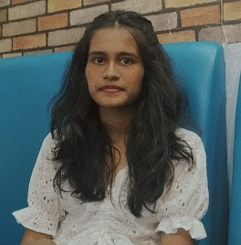 | QSpiders | Trainee Engineer | 2 LPA
15. | Ms. Swati Patil | 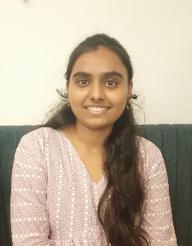 | Cyber Success  The Kiran Academy | Trainee Engineer  Trainee Engineer | 2 LPA  2 LPA
16. | Ms. Sakshi Bhanuse | 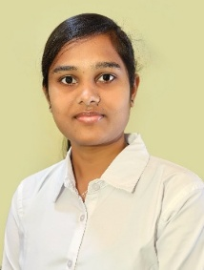 | Cyber Success | Trainee Engineer | 2 LPA
17. | Ms. Pranali Oulkar | 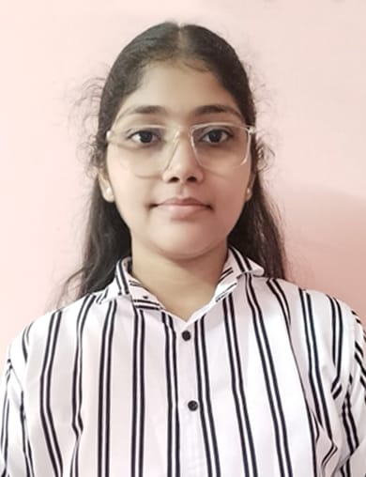 | Cyber Success | Trainee Engineer | 2 LPA
18. | Ms. Pratiksha Ekshinge | 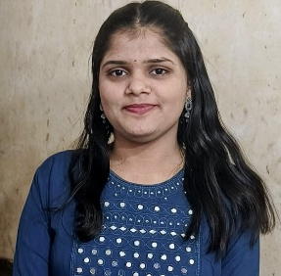 | Cyber Success | Trainee Engineer | 2 LPA
19. | Mr. Ansh Malhotra |  | The Kiran Academy | Trainee Engineer | 2 LPA
20 | Ms. Sayali Rajendra Bachal | 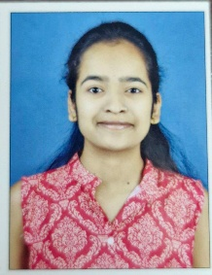 | The Kiran Academy | Trainee Engineer | 2 LPA

